Team 11
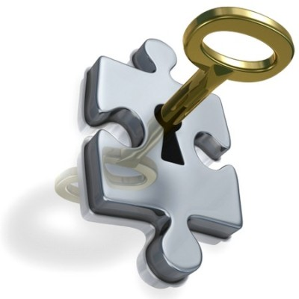 MEASUREMENT PLAN For VIKING PRJECT
SOFTWARE MEASUREMENT AND ANALYSIS
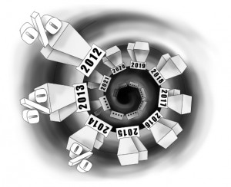
Create by: Team 11
5/26/2012

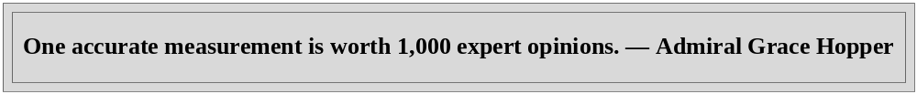
Summary
A good measurement plan contains these elements:
Goal – How would you define success or impact for your program?
Examples:
- “Congregation members will improve their physical health.”
- “Older adults will be less isolated and better connected to a supportive community.”

Outcomes – what changes in behavior or conditions do you expect from your program? Are they achievable in the short-term or intermediate-term?
Measures or Metrics – What types of measures will demonstrate that the desired outcome has been reached?
Method – What tools will you use to collect information? How will you collect information and how often?
Benchmarks – What are the targets that other organizations use to assess the success of their outcomes?
Table of contents
List of figures
List of tables

Introduction .
The document will provide information (a plan) to help manager make decision and control or measure Viking project to achieve the goals.
The GQM method is used to define necessary metrics, measurement, data collect method and goals why do you measure or what do you need to measure in project.

Purpose.
Define what metrics and data collect method need to measure Viking project. The purpose of document focus on how to collect, analysis and use data to create metrics set.
The objective of this report are to:
- Provide Goals of measurement (Present in GQM model).
- Metrics and their description.
- Present GQM model.

Scope.
In plan, we will measure the following objects were presented in GQM model.

Over view.

Establishing a Software Measurement Process
The activities required to design a measurement process:
Section 2.1 - Developing a measurement process to be made available as part of the organization's standard software process;
• Section 2.2 - Planning the process on projects and documenting procedures by tailoring and adapting the process asset;
• Section 2.3 - Implementing the process on projects by executing the plans and procedures;
• Section 2.4 - Improving the process by evolving plans and procedures as the projects mature and their measurement needs change.
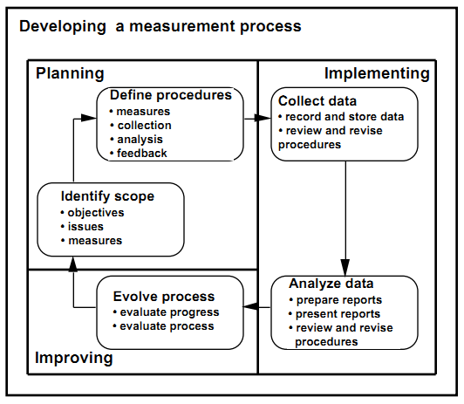
Figure 1: Software Measurement Process Architecture

12 Steps to Useful Software Metrics
If the metric is to provide useful information, everyone involved in designing, implementing, collecting data for and utilizing a software metrics must understand its definition and purpose.
